# CS 255 System Design Document

## UML Diagrams

### UML Use Case Diagram

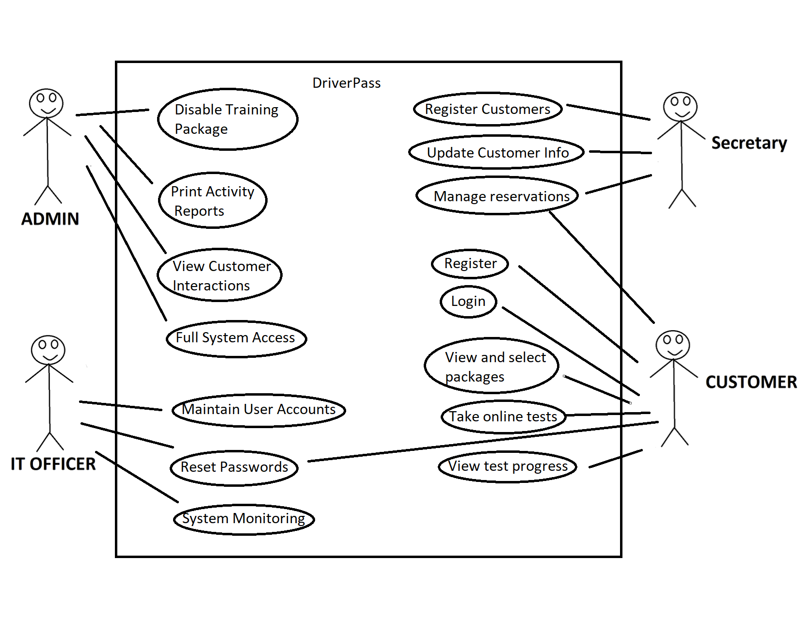

### UML Activity Diagrams

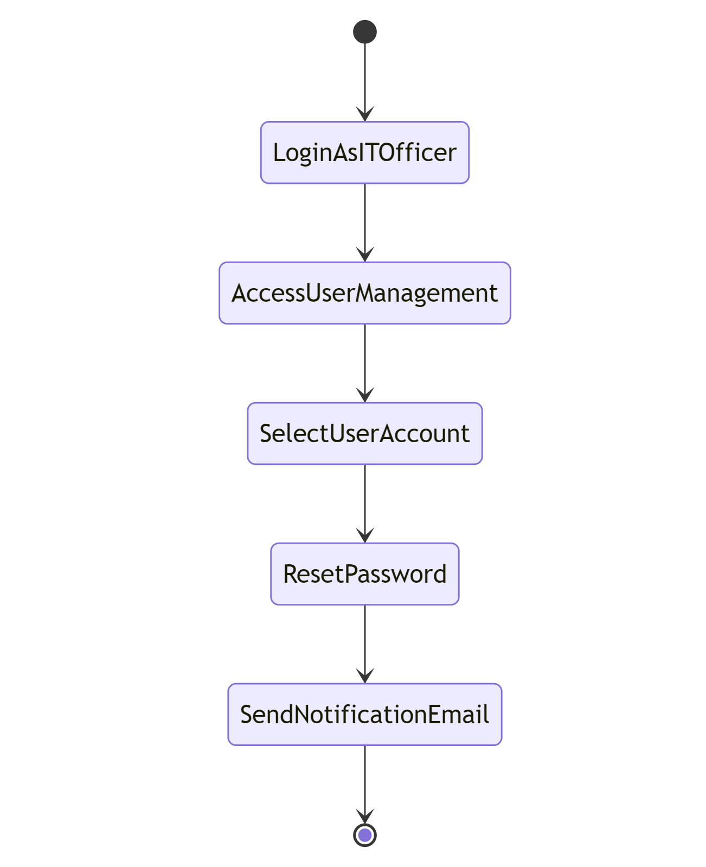

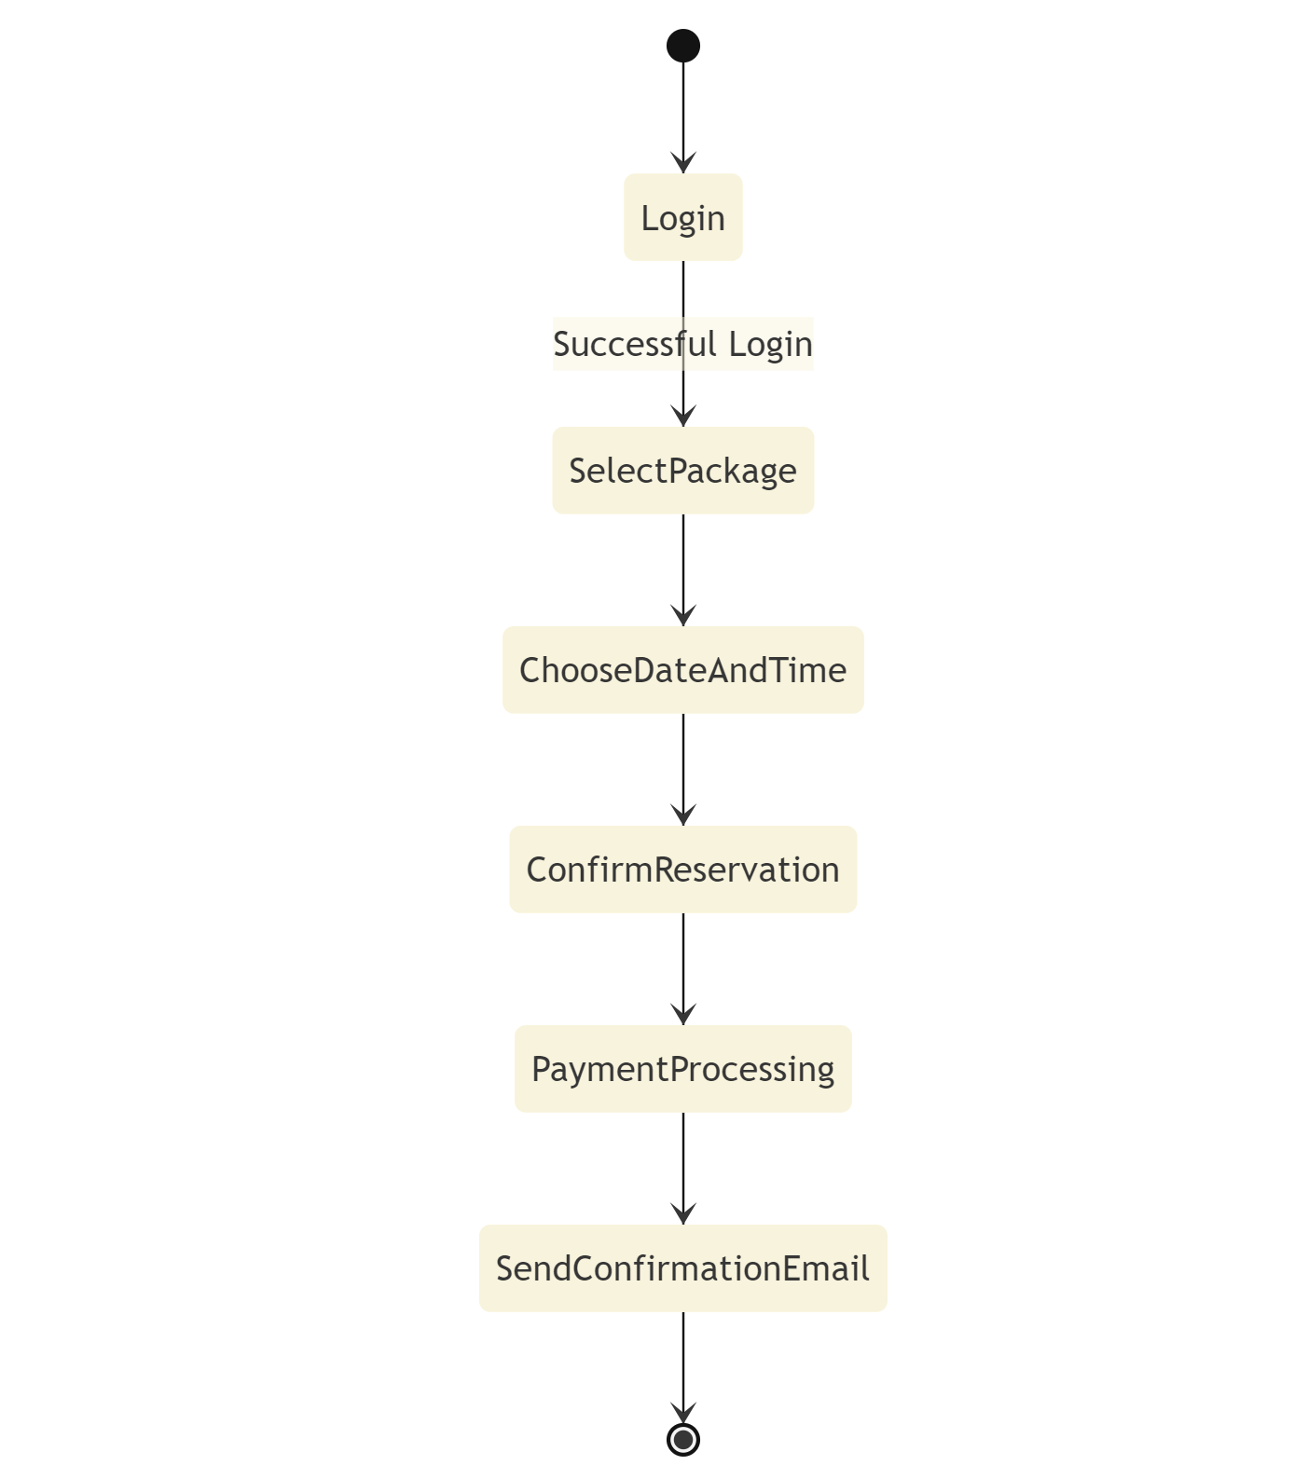

### UML Sequence Diagram

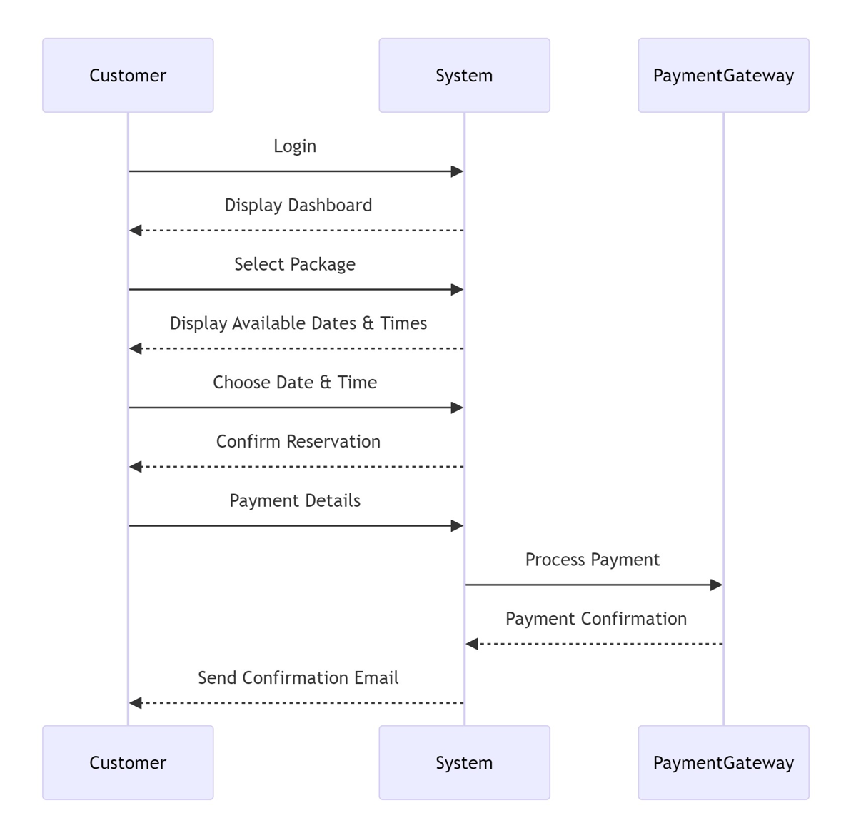

### UML Class Diagram

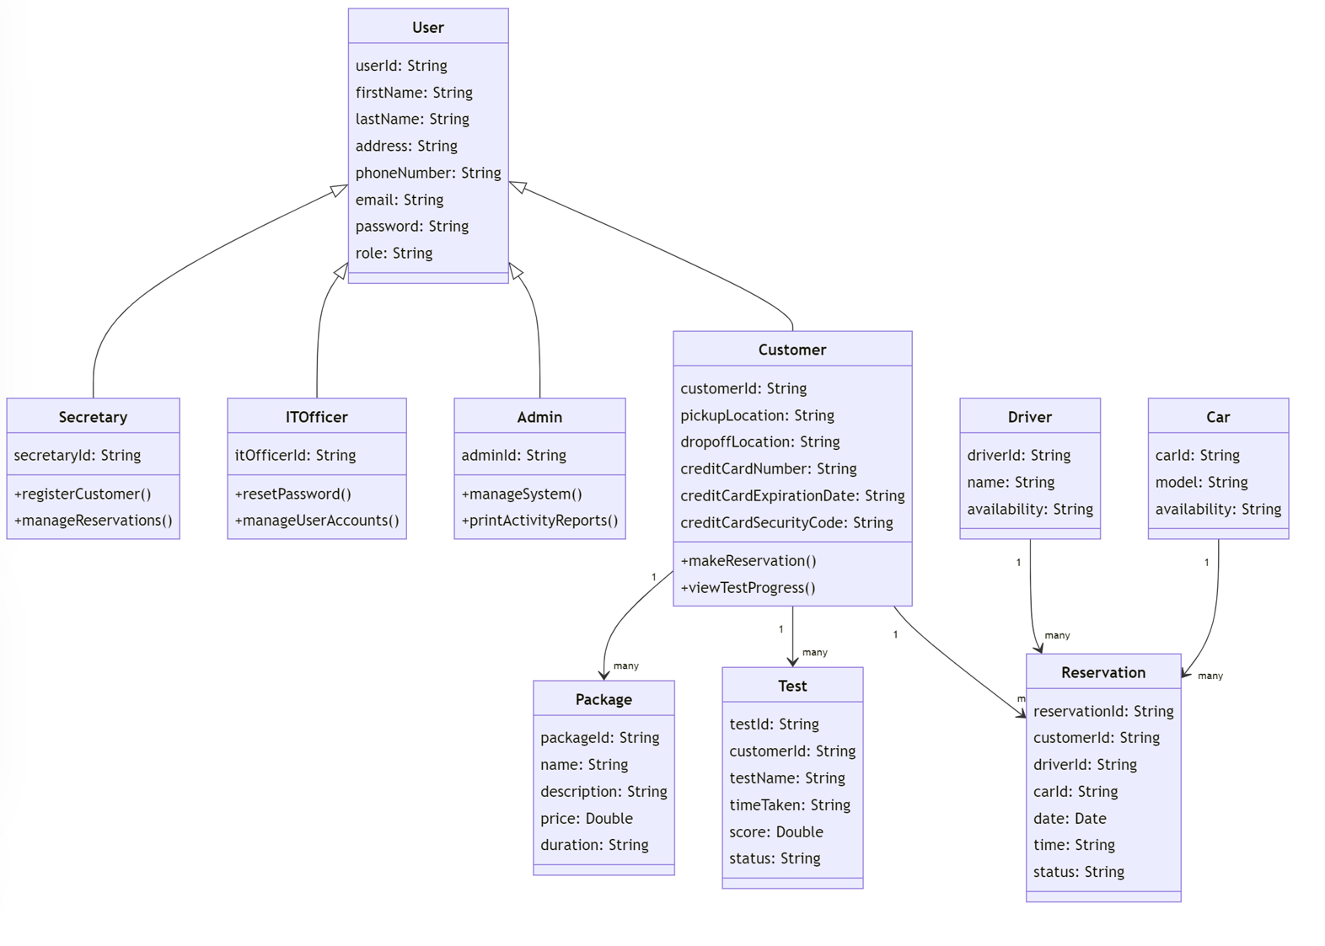

## Technical Requirements

The DriverPass system needs a strong and flexible setup to work smoothly and be easily accessible. For hardware, it will use cloud based servers to host the application, database, and storage, and it should support various user devices like computers, tablets, and smartphones.

The software requirements include supporting modern operating systems such as Windows, macOS, and Linux on user devices. The system will use web servers like Apache or Nginx to deliver web content, and databases like MySQL or PostgreSQL to store data. Development will be done using tools like Visual Studio Code, Eclipse, or IntelliJ IDEA, with Git for version control. Users will access the system through modern web browsers like Chrome, Firefox, and Safari.

For infrastructure and tools, the system will rely on a cloud service provider like AWS, Azure, or Google Cloud for hosting and additional services. Security measures include using SSL/TLS for secure communication, firewalls, and intrusion detection systems to protect the system. Automated backup solutions will make sure data is safe and recoverable, and monitoring tools like Nagios or Zabbix will keep track of server health and performance. The system will use an SMTP service to handle email notifications and confirmations, and it will integrate with a payment gateway like PayPal for processing payments securely. This setup makes sure that the DriverPass system is dependable, secure, and meets all user needs effectively.